
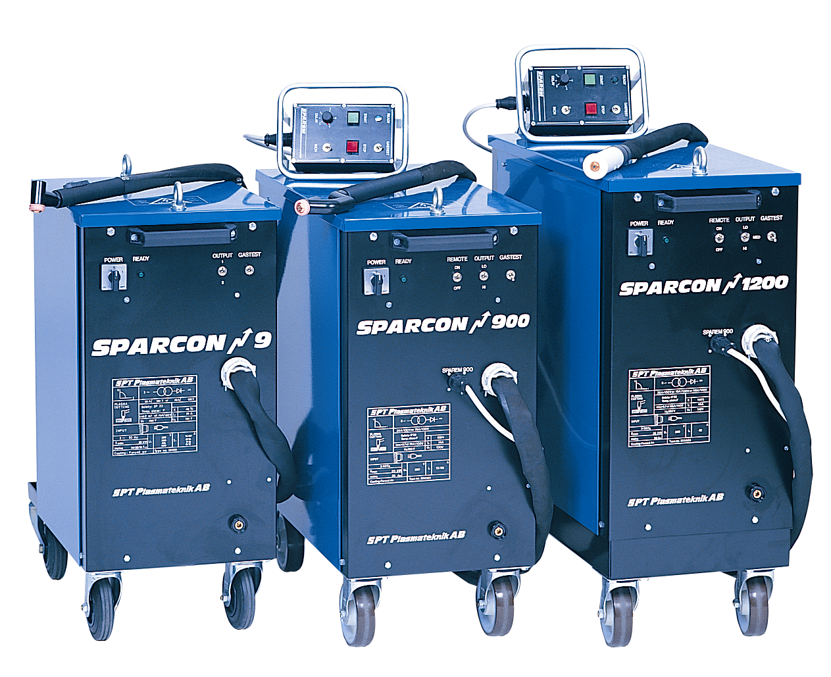

Tryckdatum 08-10-01
STATE OF THE ARC PLASMA CUTTING TECHNOLOGY
SPARCON 1200

TECHNICAL DATA | 9 | 900 | 1200
Power supply | Discontinued | Discontinued | 3~50 Hz  400 V
Fuse |  |  | 50 A  slow blow
Maximum power |  |  | 32 kVA
Process power |  |  | 130 V  35/70/115 A
Duty cycle |  |  | 100 %
Power factor |  |  | 0,7
Open circuit voltage |  |  | 250 V
Protection class |  |  | IP 22
Cooling |  |  | F
Temperature class |  |  | F
Dimensions LxWxH |  |  | 800x360x880
Weight |  |  | 240 kg
Maximum cutting capacity |  |  | 45 mm

SPARCON 1200 is developed for cutting with technical gases as well as compressed air. This gives optimum results with any metal. Moreover you have the ability to affect environmental effects, economy and weldability.

- Ability to reduce environmental effects
- Low gas consumption
- No HF
- Plasma gouging
- Water cooled torches guarantee excellent cutting economy
Multiplasma cutting system for heavy duty manual and mechanised cutting
Advantages
SPT Plasmateknik AB | Visiting address | Telephone | +46 46-18 48 00
Box 4137 | Höstbruksvägen 14 | Telefax | +46 46-18 48 09
SE-227 22 LUND | 226 60 LUND | Email | info@spt.se
Sweden | Sweden | Internet | www.spt.se

